USER GUIDE
Account Lockout
Investigation
Find out why an account keeps locking out — and which machine is doing it.
For: service desk staff handling "my account keeps locking out" tickets. No Active Directory experience needed.
Tool: Start-LockoutWorkbench.ps1 (runs Invoke-ADLockoutInvestigation.ps1)
Updated: October 2026

NOTE How to use this guide
Sections 1 to 4 take you from nothing to a finished investigation in about ten minutes. Sections 5 to 11 explain each tab of the report. Section 12 has step-by-step recipes for the tickets you will see most. If something goes wrong, go to section 13.
The last page is a quick reference card you can print and keep by your desk.
Every name, computer and screenshot in this guide comes from a made-up company (Contoso). Your report will show your own domain.

Contents
1. What this tool does 3
2. Before you start 4
3. Running the investigation 5
4. When it finishes 9
5. Reading the report — start with Findings 10
6. Can We Trust This Data 12
7. Who Is Locking Out 14
8. Why This Account 15
9. Which Device 18
10. What To Fix 20
11. Device Timeline 23
12. Common tasks 24
13. Troubleshooting 26
14. What to put in the ticket 28
Quick reference card 30

1. What this tool does
An account locks when someone, or something, types the wrong password too many times in a row. When it keeps happening, the cause is almost never the person typing. It is usually a device that still remembers an old password — an old laptop, a phone set up for email, a mapped drive, a saved Remote Desktop login — and keeps trying it in the background.
This tool reads the domain controllers' records of those failed attempts and tells you which machine is sending the wrong password, and what is most likely to fix it.
TIP Why "I keep having to reset my password" is often a lockout
A user who says they are "forced to reset" far more often than usual is usually being locked out. Each time, they (or you) reset the password to get back in — but the old password is still saved somewhere, so the lockouts start again. Resetting treats the symptom. Finding the device fixes it.

Use it to
- See which accounts have been locking out recently, even if you do not know the username yet.
- Find the computer, server or phone that is sending the wrong password for one account.
- Tell a single stale password apart from something more serious, such as many accounts locking out at once.
- Attach one folder to a ticket as evidence of what you found.

It does not
- Change anything. It only reads. It never unlocks an account, resets a password, or changes a setting.
- Read Microsoft 365 / Entra ID sign-in logs. It looks at the on-premises domain. If the report finds nothing, the cause may be on the cloud side (section 13).
- Fix the device for you. It tells you where to look. Removing the old password from the device is a separate step (section 12C).

Who does what
Your AD admin in this guide means whoever looks after Active Directory where you work — a senior engineer, a systems team, or an outside IT provider. If you are not sure who that is, ask whoever gave you this tool.
Task | You | Your AD admin
Run the investigation and read the report | ✓ | ✓
Unlock the account or reset the password | Through your normal process | ✓
Clear an old password from the user's own PC, phone or mapped drive | ✓ (with the user) | ✓
Fix a service, scheduled task or server that is using an old password |  | ✓
Turn on lockout auditing when the tool says STOPPING |  | ✓
Run with extra options (-Force, -MultiForest, Entra Connect server) |  | ✓
Change the domain's lockout policy |  | ✓
Turn on lock/unlock auditing on PCs (used by the Device Timeline) |  | ✓

2. Before you start
Tick these off before you run the investigation.
- You are on a domain-joined computer on the company network, or connected to the VPN.
- The computer has the Active Directory tools (RSAT). Domain controllers and most admin servers already do. If not, the tool tells you straight away (section 13).
- You can sign in with the account your team uses for this tool. It must be allowed to read the Security logs on the domain controllers. Your everyday account usually cannot — ask your AD admin which account to use.
- You have the whole folder. The scripts work together, so keep every file in AD-LockoutDiagnostics side by side. The ones you will notice are:
  - Start-LockoutWorkbench.ps1 — the menu you start
  - Invoke-ADLockoutInvestigation.ps1 — runs the eight steps
  - New-LockoutCaseReport.ps1 — builds the one report you open
TIP You do not need the username to start
The menu shows every account that has locked out recently. If the ticket just says "someone in Accounts keeps getting locked out", start the tool and pick from the list.

NOTE Why the account matters
One check (step 1, "is anything being logged?") needs administrator rights on the domain controllers. With a more limited account the investigation still runs and says plainly that it could not read the audit settings. If it then finds lockouts, the summary says PARTLY CONFIRMED — finding lockouts proves they are being recorded. That is fine for most tickets; just mention it in the ticket.

3. Running the investigation

Step 1 — Copy the folder
Copy the whole AD-LockoutDiagnostics folder to the computer you will run it on. C:\Tools is a good place. Do not copy just one file.

Step 2 — Open PowerShell in the folder
Open Windows PowerShell as the account your team uses for this tool. (If you are signed in as yourself, hold Shift, right-click Windows PowerShell and choose Run as different user.) Then type these three lines, pressing Enter after each:
Set-Location C:\Tools\AD-LockoutDiagnostics
Get-ChildItem | Unblock-File
Set-ExecutionPolicy -Scope Process -ExecutionPolicy Bypass -Force
The second line tells Windows the files are safe to run. The third allows scripts in this window only — it goes back to normal when you close the window.

Step 3 — Start the workbench
.\Start-LockoutWorkbench.ps1
The tool scans the domain for lockouts in the last 7 days and lists the accounts, worst first:
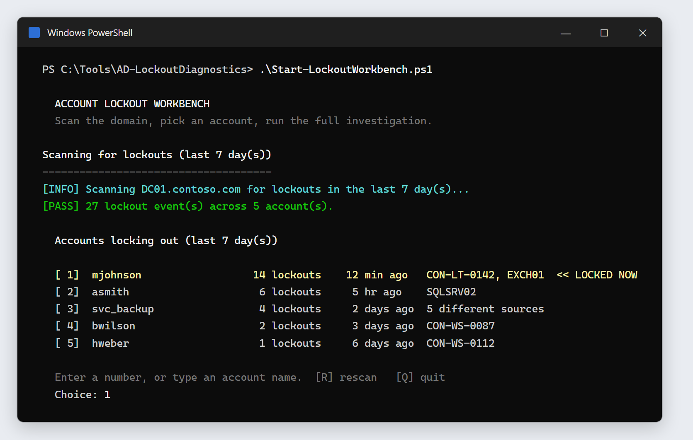
Figure 1 — The workbench menu. Marcus Johnson (mjohnson) is locked right now, so his row is yellow.
Column | What it tells you
[ 1] | The number to type to pick this account.
mjohnson | The username.
14 lockouts | How many times it locked in the last 7 days. One or two is normal; double figures means something keeps trying.
12 min ago | When it last locked.
CON-LT-0142, EXCH01 | Where the lockouts came from. 5 different sources means many machines — read section 12E.
<< LOCKED NOW | The account is locked at this moment. The row is shown in yellow.

Step 4 — Pick the account
Type the number next to the account and press Enter. If the account you need is not listed, type its username instead. R scans again; Q quits.
NOTE An empty list is not the same as "no problem"
If the scan finds nothing, the tool says there are two possible reasons: nothing is locking out, or the domain controllers are not recording lockouts. Type the username anyway — the investigation checks which it is before it does anything else.

Step 5 — The Entra Connect question
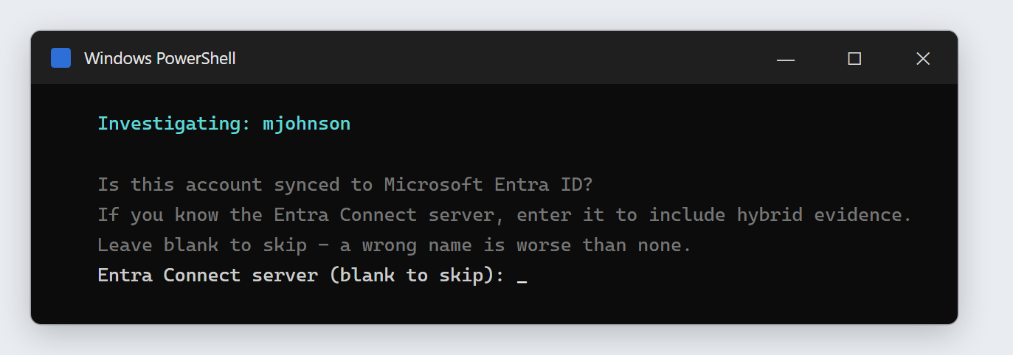
Figure 2 — Press Enter to skip unless your AD admin has given you the Entra Connect server name.
Entra Connect is the server that copies accounts to Microsoft 365. Naming it adds evidence from that server. Press Enter to skip unless you have been given the exact name — a wrong name is worse than none, because the tool would check the wrong server and report it as healthy.

Step 6 — Let it run
The investigation runs eight steps in order. Lines scroll past — that is normal. Yellow [WARN] lines are information, not failures. Do not close the window. A small domain takes a few minutes; a large one with a long history can take longer.
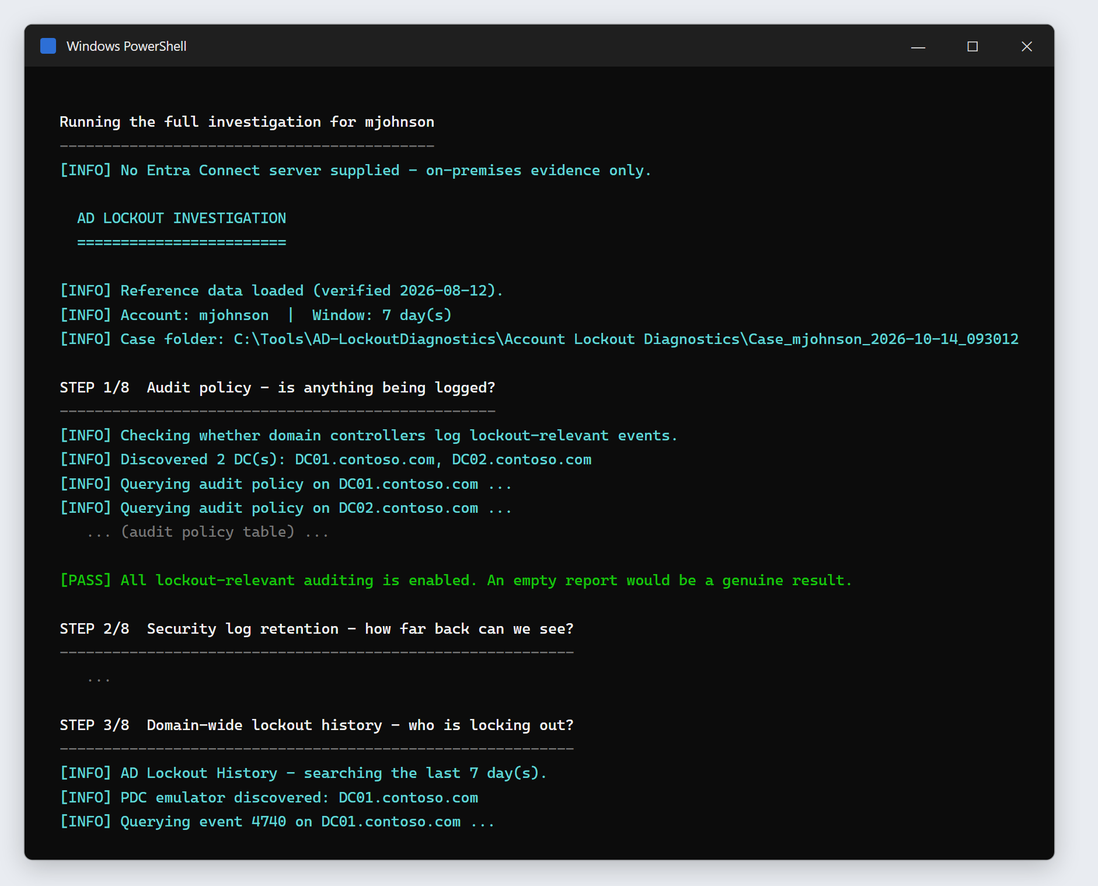
Figure 3 — The investigation running. Step 1 passed, so the rest of the steps can be trusted.
Step | Question it answers | Report tab
1 | Are the domain controllers recording lockouts at all? | Can We Trust This Data
2 | How far back do their logs reach? | Can We Trust This Data
3 | Who is locking out across the whole domain? | Who Is Locking Out
4 | Why this account — when, and from where? | Why This Account
5 | Which domain controller or forest? (only with extra options — usually skipped) | Which DC Or Forest
6 | Which physical device is behind each address? | Which Device
7 | What is the most likely cause, and how is it fixed? | What To Fix
8 | Was that machine on, asleep or locked when the failures came? (top 3 workstations) | Device Timeline

IMPORTANT If it says STOPPING
If step 1 finds that the domain controllers are not recording lockouts, the tool stops on purpose — any report it produced would be empty and look like a clean result. This is a real finding, not a fault in the tool. See section 13.

4. When it finishes
The window prints the case summary — the findings first, then what was checked — and finishes with the one file to open:
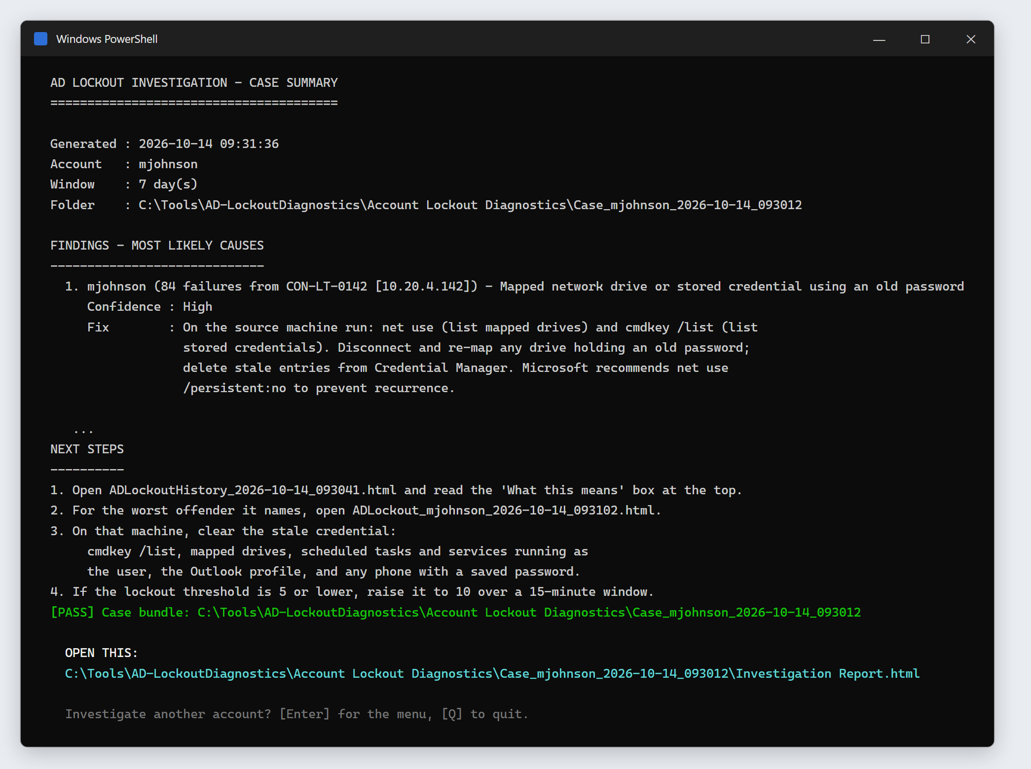
Figure 4 — The end of the run. The path under OPEN THIS is the report to open.

Open the report
- Select the path under OPEN THIS: with the mouse and press Enter to copy it (or right-click, depending on your PowerShell window).
- Press Windows key + R, paste the path, and press Enter. The report opens in your web browser.
- Alternatively, open File Explorer, go to the folder shown after Case bundle:, and double-click Investigation Report.html.
Press Enter in the PowerShell window to go back to the menu for another account, or Q to quit.

Where the files are
Every run gets its own case folder named after the account and the time, inside an Account Lockout Diagnostics folder next to the scripts:
C:\Tools\AD-LockoutDiagnostics\Account Lockout Diagnostics\
Case_mjohnson_2026-10-14_093012\
In the case folder | What it is
Investigation Report.html | Everything combined into one page with tabs. This is the file to open.
SUMMARY.txt | The findings as plain text, for pasting into the ticket.
READ ME FIRST.txt | A map of the folder, for anyone who opens it cold.
1 - Can We Trust This Data … 6 - Device Timeline | The individual reports behind each tab, if someone wants one on its own.
*.log | What each step printed. Your AD admin may ask for these if something went wrong.

STOP The case folder is confidential
It lists real usernames, computer names and IP addresses. Attach it to the ticket — do not email it around, post it in chat, or save it to OneDrive or a shared drive.

5. Reading the report — start with Findings
The report is a single web page. It needs no internet connection. Along the top: the case name, when it was made, a blue bar naming the account you investigated, and the tabs.
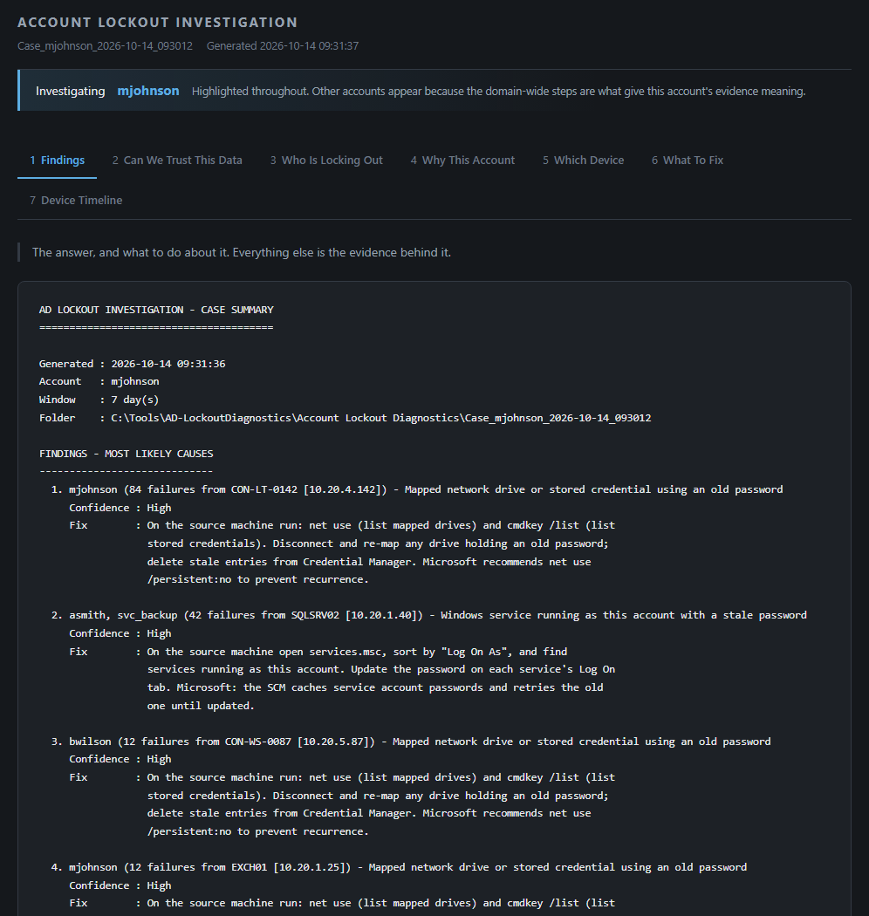
Figure 5 — The Findings tab. The answer comes first; everything below it is the evidence.
Tab | Answers the question
Findings | What is the answer, and what do I do about it?
Can We Trust This Data | Were the domain controllers recording? Can an empty section be believed?
Who Is Locking Out | Is it just this account, or many?
Why This Account | When did it lock, and where did the wrong passwords come from?
Which Device | What is the actual computer behind each address?
What To Fix | Most likely causes, ranked, with the fix for each.
Device Timeline | Was the machine on, asleep or locked when the failures came?

Your account is highlighted in blue everywhere it appears. Other accounts are shown on purpose: knowing whether one account or forty are locking out changes what the answer means.

What the Findings tab says
It is the same text as SUMMARY.txt, in this order:
Heading | What to do with it
FINDINGS - MOST LIKELY CAUSES | The answer. Each line names a source machine, how many failures came from it, and the likely cause, with a confidence and the fix.
EVIDENCE QUALITY | Whether lockouts were being recorded. If this says NOT TRUSTWORTHY, any empty section is a gap in the records, not a clean result. PARTLY CONFIRMED means your account could not read the audit settings, but lockouts were found, so lockout recording works.
STEPS RUN | OK, SKIPPED or EXIT n for each step. A skipped step 5 is normal.
FILES IN THIS FOLDER | Every report in the case folder, in reading order.
NEXT STEPS | What to do now, in plain steps.

TIP Reading the findings list
Findings cover every source the tool saw, not only your account — in the example, finding 2 is about asmith and svc_backup on a server. Look for the lines that start with your account name.
The failure count includes the lockouts themselves, so it is usually higher than the lockout count.

6. Can We Trust This Data
This tab answers the question every other tab depends on: were the domain controllers actually recording failed sign-ins and lockouts? A report can only find what was recorded. "No evidence found" and "nothing was recorded" look identical unless you check here.
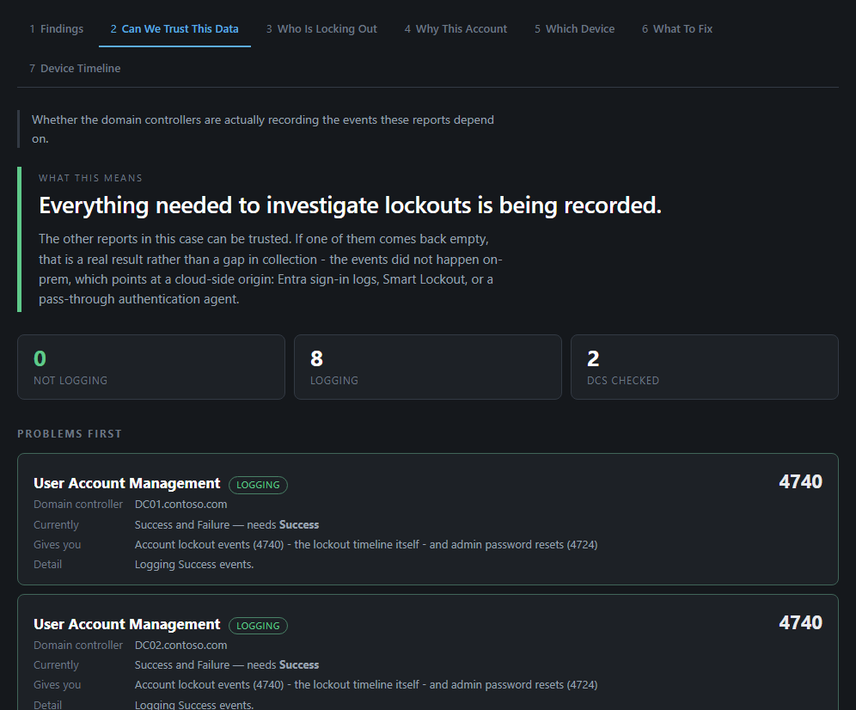
Figure 6 — Can We Trust This Data. Both domain controllers are recording everything, so the rest of the report can be believed.
The coloured box at the top, What this means, gives the verdict. The tiles count the checks that are Not logging and Logging, and how many domain controllers were checked. Below, Problems first lists one card per check per domain controller, with anything wrong at the top.
You see | What it means
Green: "Everything needed to investigate lockouts is being recorded" | Good. The rest of the report can be trusted — including any tab that comes back empty.
Amber: lockouts recorded, but an event is missing | Some supporting evidence is missing on one domain controller, so parts of the report may be thin. Mention it in the ticket.
Red: lockouts are not recorded on a domain controller | The lockout records themselves are missing. The tool stops at this point (section 13). Pass this tab to your AD admin.
"Security log retention is under 7 days" | The logs only reach back a few days, so older lockouts have already been overwritten.
Grey: "Audit policy could not be read" | Your account is not an administrator on the domain controllers, which this check needs. The rest still ran, and any lockouts it found are real. Mention it in the ticket.

7. Who Is Locking Out
Every account that locked out in the window, ranked by how often. Use it to answer: is this one person's old password, or something bigger?
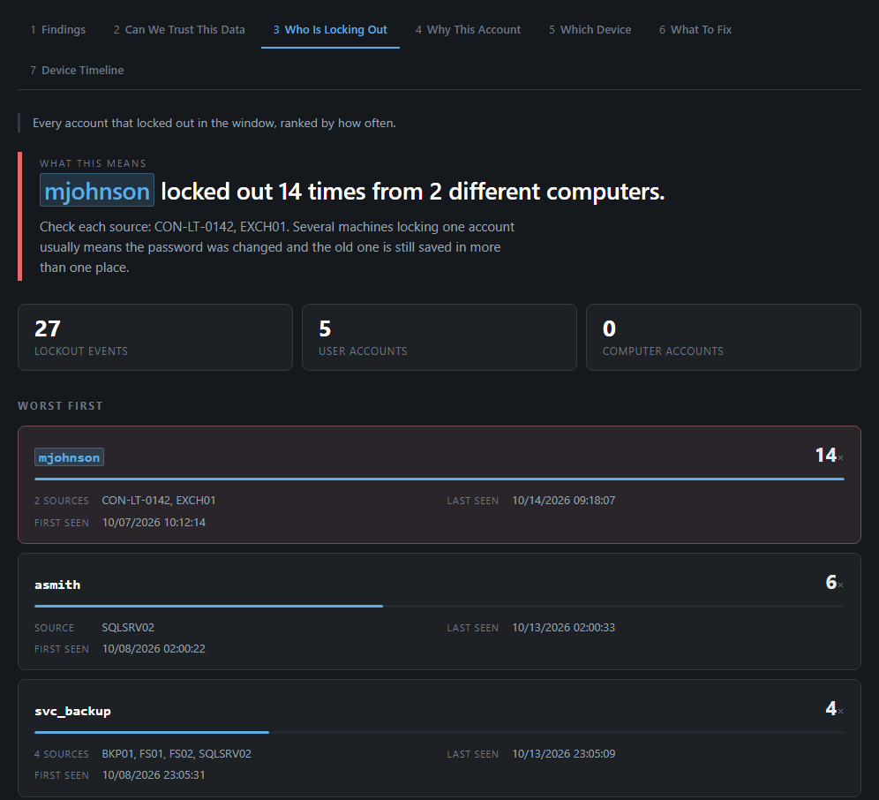
Figure 7 — Who Is Locking Out. mjohnson locked 14 times from two computers; the other accounts lock far less often.
The box at the top says what the pattern means. Each card below shows one account: how many times it locked, the computers it locked from (Source), and when it first and last locked. Expand Every lockout event at the bottom for the full list.
- One account far ahead of the rest — almost always a stale password on one device. Carry on with the other tabs.
- Many accounts at once, all from the same source — that machine is trying lots of accounts. Hand it to your AD admin straight away (section 12E).
- A service account (often starting svc_) — a program or server is using an old password. Hand it to your AD admin (section 12D).
- Caller computer "(not recorded)" — the domain controller could not tell which machine it was. The Which Device tab may still find it from the IP address.

8. Why This Account
The deep dive on the account you picked: where the wrong passwords came from, when the account locked, its current state and lockout rules, and any password resets.
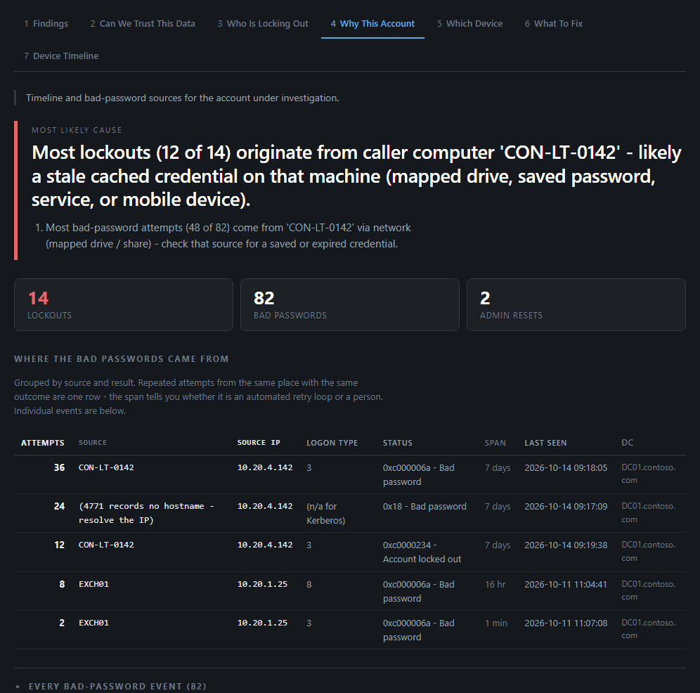
Figure 8 — Why This Account. 12 of the 14 lockouts came from CON-LT-0142, over the network — a mapped drive or saved password.

Reading it top to bottom
Section | What to look at
Most likely cause | The tool's best explanation, with supporting points underneath. Read this first.
Lockouts / Bad passwords / Admin resets | The counts. Bad passwords can be higher than you expect — they include tries made after the account was already locked.
Where the bad passwords came from | One row per source and result: how many attempts, the machine and IP, the logon type (table below), the status, and the span — a short burst means a program retrying, not a person typing.
Every bad-password event | Click to expand every single failed attempt, if you need exact times.
When it locked | Each lockout with its caller computer — the machine that sent the wrong password. The same name over and over is the strongest clue you will get.
Account state and lockout policy | Click to expand. Is it locked now? When was the password last changed? How many wrong passwords lock it? Lockouts that start right after a password change point at a device with the old one saved. A limit of 3 or fewer makes lockouts much more likely — mention it to your AD admin.
Admin and helpdesk password resets | Who reset the password, and when. Resets with lockouts in between is the "keeps having to reset" pattern.
Entra Connect / hybrid authentication | Only filled in when an Entra Connect server was named in step 5. Otherwise it says it was not run.

What the status tells you
Status | Meaning
0xc000006a - Bad password | Wrong password (failed sign-in, event 4625).
0x18 - Bad password | Wrong password, from a Kerberos sign-in (event 4771). These rows carry an IP address but no computer name — the Which Device tab resolves it.
0xc0000234 - Account locked out | Tries made after the account was already locked. They confirm the same source kept going.

Codes as documented by Microsoft for events 4625 and 4771 (learn.microsoft.com).

What the logon type tells you
The logon type number says how the wrong password was used. That points you at what to check on the machine.
Type | Name | Usually means — check this
2 | Interactive | Someone typing at the keyboard of that machine. Often just the user mistyping.
3 | Network | A mapped drive, shared folder, printer or app connecting over the network. Check mapped drives and saved Windows credentials.
4 | Batch | A scheduled task running as the user. Hand to your AD admin if it is on a server.
5 | Service | A Windows service set to run as the user. Hand to your AD admin.
7 | Unlock | Someone unlocking a locked screen with the old password.
8 | NetworkCleartext | Often web or mail sign-ins (for example a phone collecting email through an Exchange server). Check the user's phone and tablets.
10 | RemoteInteractive | A Remote Desktop session, often a disconnected one still signed in with the old password.
11 | CachedInteractive | A laptop signing in with a remembered password while away from the network.

Logon types are defined by Microsoft for event 4625 (learn.microsoft.com, "4625(F) An account failed to log on").

9. Which Device
The other tabs often name a source by IP address. This tab works out what that address actually is: its computer name, what kind of device it is, and how sure the tool is.
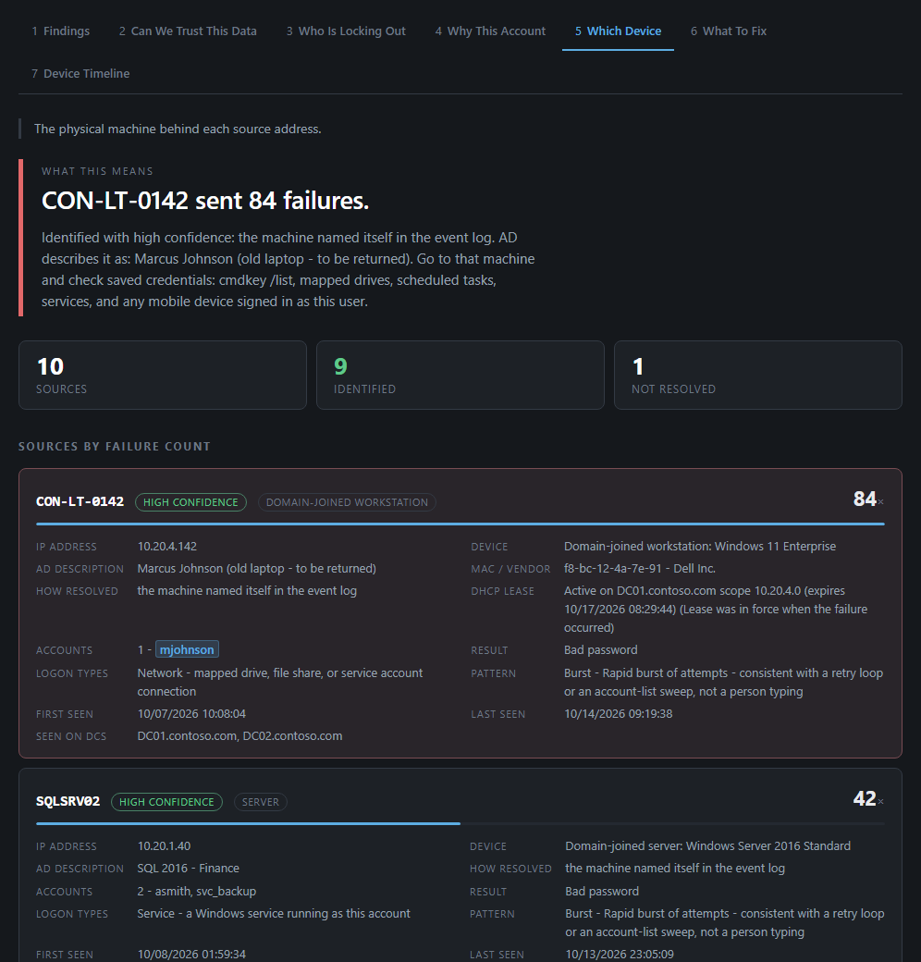
Figure 9 — Which Device. 10.20.4.142 is CON-LT-0142, which AD describes as Marcus Johnson's old laptop.
On each card | What it tells you
Name + confidence | The machine to go to. High confidence means it named itself in the records.
AD description | What Active Directory says about the computer — often who uses it, or that it is an old or spare machine. The quickest way from a name to a person.
Device | What kind of machine: workstation, server, and its Windows version. Server usually means a service or task — hand it to your AD admin.
MAC / Vendor | The network card's maker, when known. A phone maker usually means a phone or tablet. Often blank — that is normal.
DHCP lease | Whether the address was handed out by your DHCP server, and when.
Accounts | Which accounts this machine failed for. More than one account from a workstation is unusual — mention it.
Logon types | The same idea as section 8, in words: for example "Network - mapped drive, file share…".
Pattern | Burst = a program retrying quickly. Irregular = more like a person, or several unrelated things.

- A mail server (such as EXCH01) as the source usually means the failures pass through it from somewhere else — most often a phone collecting email. Check the user's phone; the server itself is not the culprit.
- Not resolved — the tool could not work out what the device is. It may be personal or unmanaged. Ask the user what else they sign in from.

10. What To Fix
This tab puts the evidence together and lists the most likely causes, ranked, each with how sure the tool is and what to do.
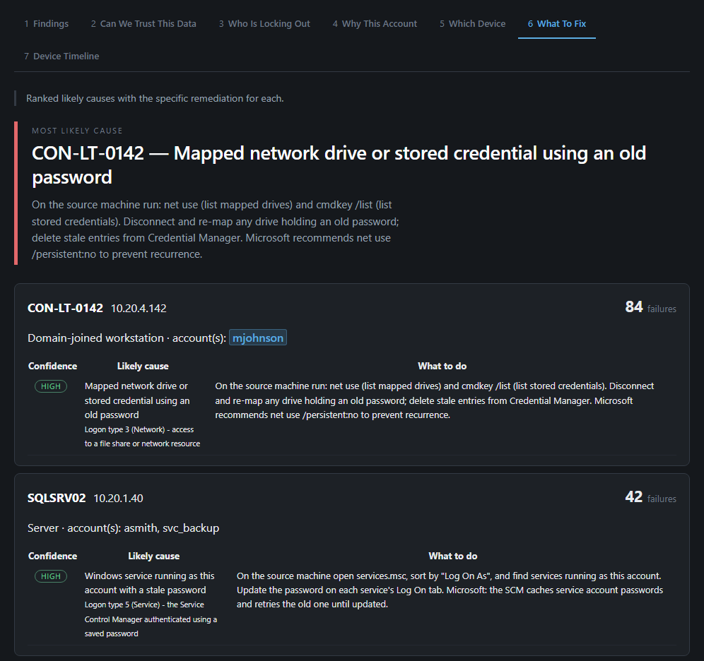
Figure 10 — What To Fix. The top cause is a saved old password on CON-LT-0142, with high confidence.

Reading a cause card
- The heading names the source machine and how many failures came from it.
- Confidence — High (green) means the evidence points clearly at one thing. Medium or Low (amber) means the tool is less sure; check the machine yourself.
- Likely cause — what is probably holding the old password. The small text underneath says which evidence led there (for example the logon type).
- What to do — the specific steps for that cause.

What each cause means
Cause (as the report says it) | In plain English | Who fixes it
Mapped network drive or stored credential using an old password | A mapped drive or a saved password in Credential Manager on that machine still has the old password. Also shown for many phone and web mail sign-ins. | You, with the user (section 12C)
Cached credentials on a console session after a password change | Someone is signed in at that PC with the old password still in memory. Lock and unlock (Windows key + L), or sign out and back in. | You, with the user
Disconnected Remote Desktop / Terminal Server session | An old Remote Desktop session is still open on that machine with the old password. | You (sign the user out), or your AD admin on servers
Personal or mobile device with an old saved password | A phone, tablet or home PC that is not in Active Directory. Have the user update or remove the saved account. | You, with the user
Windows service running as this account with a stale password | A program on that machine runs as this account and keeps trying the old password. | Your AD admin
Scheduled task with expired credentials | A scheduled job on that machine runs as this account with the old password. | Your AD admin
RunAs /netonly or an application supplying explicit alternate credentials | A shortcut, script or app on that machine has the account's password typed into it. | Your AD admin
Source is a gateway … the real device is behind it | The address is a VPN, firewall or similar. The real device is somewhere behind it. | Your AD admin
Shared server or service authenticating for N accounts | One server is failing for several accounts — usually one shared setting with an old password. | Your AD admin
One device failing against multiple accounts — possible password spray | One device is trying many accounts. This can be an attack. | Escalate now (section 12E)
Unidentified device - not in AD, DHCP or DNS | The tool could not work out what the device is. Treat it as a security question too. | Your AD admin
Authentication relayed through a domain controller | The failures arrive via a domain controller; the real source is further back. | Your AD admin
Legacy NTLM authentication only / Kerberos-only source | The records do not name the machine, only an address (or nothing). It is usually an old device, appliance or non-Windows system. | Your AD admin
Insufficient evidence to suggest a cause | Not enough detail to say — often a machine seen only in the lockout records. Check the machine directly. | You first, then your AD admin

11. Device Timeline
The other tabs come from the domain controllers, which record that a machine sent a wrong password — not what the machine was doing. This tab reads each source computer's own logs (when it started, shut down, went to sleep, woke, locked and unlocked) and lines them up against the failures. It checks the top three workstations automatically.
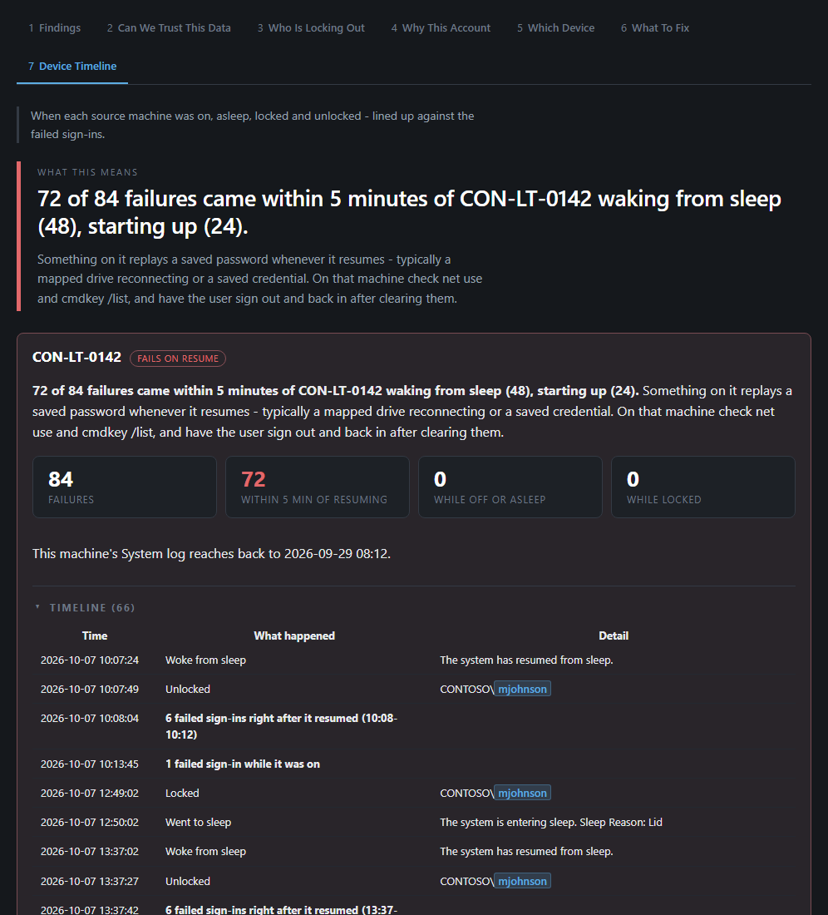
Figure 11 — Device Timeline. 72 of 84 failures came within 5 minutes of CON-LT-0142 waking or starting up.
The tab says | What it means
Failures within 5 minutes of it waking, starting up or being unlocked | Something on that machine replays a saved password when it resumes — usually a mapped drive reconnecting. This confirms the machine. Clear the old password there (section 12C).
It was shut down or asleep for most failures | A machine that is off cannot send passwords, so it is probably not the source, even though the other tabs name it. Something else has its address or name. Tell your AD admin before clearing anything.
Failures happened while it was locked | Nobody was typing. A service, scheduled task, mapped drive or app signed in as the user sent them.
It was on and awake for the failures | No pattern either way. Go by the other tabs.
It could not be reached | It is off, off the network, or blocks remote log reads. If failures keep arriving while it is off, it is not the source.

- Timeline (click to open) — every start, shutdown, sleep, wake, lock and unlock, with each run of failures shown as one line, such as "6 failed sign-ins right after it resumed".
- Lock and unlock only appear if that PC records them. If it does not, the card says so — startup, shutdown, sleep and wake are always checked.
- Modern Standby (many newer laptops) keeps the network on while the screen is off. Failures then do not prove the laptop was idle, and the tab never treats them that way.
- Reading lock and unlock needs administrator rights on that PC. Without them, the card says so and the rest is still checked.

12. Common tasks

A. "My account keeps locking out"
- Unlock the account through your normal process so the user can work while you investigate.
- Start the workbench and pick the account (or type the username).
- Open the report. On Findings, note the top source machine and the likely cause.
- Check Which Device to find out what that machine is. Ask the user if they recognise it.
- Check Device Timeline. Failures right after it wakes or starts confirm it is the machine; failures while it was shut down mean the culprit is elsewhere.
- Clear the old password from that device (task C), then ask the user to sign out and back in everywhere.
- Next day, run the workbench again. The account should no longer appear, or show no new lockouts after your fix.

B. You do not know which account it is
- Start the workbench — do not type a username.
- Look for the yellow << LOCKED NOW rows and the highest lockout counts.
- Match the list to the ticket (department, computer name in the "where from" column) and pick the number.

C. Clearing an old password from a device
Do this with the user, on the machine the report named. Check each place in turn:
Where | How
Saved Windows passwords | Control Panel → Credential Manager → Windows Credentials. Remove entries for the domain, file servers or mail. Or run cmdkey /list to see them.
Mapped drives | File Explorer → This PC. Disconnect drives that show an error, and map them again after the user signs in with the new password.
Phone or tablet email | Update the password in the mail app (or remove and re-add the account). An old phone in a drawer still trying to sync is a common culprit.
Remote Desktop sessions | Sign the user out (not just disconnect) of any server or PC they remote into.
An old laptop or PC | Shut it down or sign the user out. If it should be returned, raise that with whoever manages equipment.
Scheduled tasks, services, apps on a server | Not a service desk change — hand it to your AD admin with the report.

D. A service account is locking out
Accounts used by programs (often named svc_…) lock out when the password was changed but a server, service or scheduled task still uses the old one. Do not reset the password yourself — that can break the program. Attach the case folder and hand it to your AD admin, naming the source machines from Which Device.

E. Many accounts locking out at once
STOP This may be an attack — escalate straight away
If Who Is Locking Out shows many accounts locking out together, or one account failing from many different or unknown machines, do not keep unlocking accounts. Attach the case folder and escalate to your AD admin or security team immediately, following your security incident process.

F. Confirming the fix worked
- Wait at least a few hours of normal use — or until the next working day.
- Run the workbench again. Pick the account, or check it no longer appears.
- In Why This Account, check that no new lockouts appear after the time you made the fix. Note this in the ticket.

13. Troubleshooting
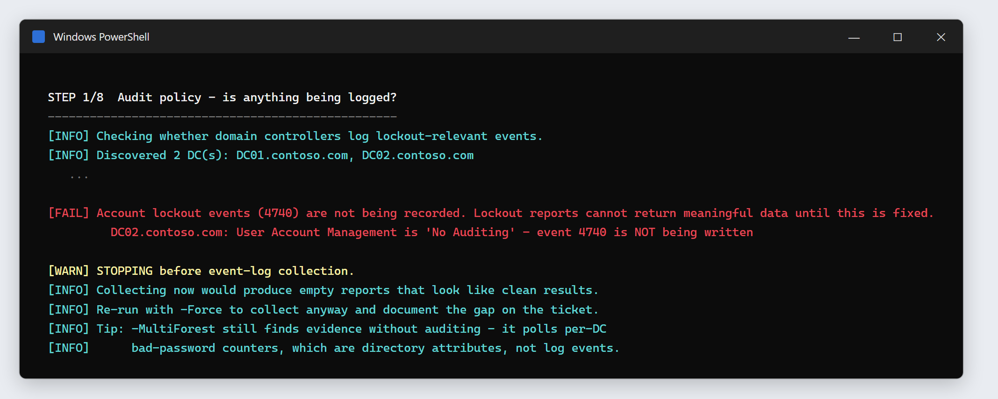
Figure 12 — The investigation stopping because one domain controller is not recording lockouts. This is a finding to pass on, not an error.
What you see | What it means | What to do
.ps1 cannot be loaded because running scripts is disabled | Scripts are blocked in this window. | Run the Unblock-File and Set-ExecutionPolicy lines from section 3, step 2, then try again.
The ActiveDirectory module is not available / ActiveDirectory module not found | This computer does not have the Active Directory tools. | Run it on a domain controller or admin server, or ask your AD admin to install RSAT.
Could not read the Security log on DC01… (often "Access is denied") | Your account cannot read the domain controllers' logs. | Use the account your team set up for this tool. Still failing? Pass it to your AD admin.
Could not determine the PDC emulator / Could not contact the domain | No connection to the domain. | Check the network or VPN, and that you signed in with a domain account.
No account lockouts were recorded on the PDC… | Nothing locked out — or nothing is being recorded. | Type the username anyway. Step 1 will tell you which.
STOPPING before event-log collection | The domain controllers are not recording lockouts. | Pass the case folder to your AD admin: auditing needs turning on. Re-run after the problem happens again.
Audit policy could not be determined or Access denied: reading audit policy needs administrator rights | Your account is not an administrator on the domain controllers. | Carry on. If lockouts were found, the summary says PARTLY CONFIRMED. Mention it in the ticket.
Could not resolve identity '…' | The username was not found. | Check the spelling. Use the username (for example mjohnson), not the display name.
Security log on DC01 only reaches back N day(s) | Older events have been overwritten. | Lockouts before that are not in the report. Mention it; your AD admin can enlarge the logs.
A step shows EXIT 1 or a yellow Exited with code… | One step hit a problem; the rest still ran. | Use the report as normal. Attach the matching .log file from the case folder.
Report is empty but the user is definitely locking out | The failures may be coming from Microsoft 365 (cloud) sign-ins. | Hand it to your AD admin to check Entra ID sign-in logs, mentioning the account is synced.
Device Timeline: could not be reached | The PC is off, off the network, or its firewall blocks remote event log reads. | Check it is on and connected, then run the investigation again. If failures keep arriving while it is off, it is not the source.
Device Timeline: No lock or unlock events were found | Lock/unlock auditing is not turned on for that PC. | Nothing to do — startup, shutdown, sleep and wake were still checked. Your AD admin can turn the auditing on.
The report looks plain, or the tabs do not work | An old browser, or scripts blocked in the browser. | All sections still show, one after another. Or open it in Edge or Chrome on your own PC.

When to hand it to your AD admin
- The tool says STOPPING, or it cannot read the domain controllers with the account you were given.
- The source is a server, a scheduled task or a service — or the account is a service account.
- Many accounts are locking out, or the failures come from many different or unknown machines.
- The report is empty but the account keeps locking — the cause may be in Microsoft 365.
- The lockout policy is very strict (3 attempts or fewer), or you need an option such as -Force or -MultiForest.

14. What to put in the ticket
Include | Example
The zipped case folder, attached | Case_mjohnson_2026-10-14_093012.zip
The account and how many lockouts | mjohnson — 14 lockouts in 7 days, locked at time of run
The top finding in one sentence | "Old password on a mapped drive on CON-LT-0142 (Marcus's old laptop): 84 failures, high confidence."
What you did about it | Signed out and shut down CON-LT-0142; laptop to be returned. Account unlocked.
Anything yellow or red you saw | "Audit policy could not be determined" — screenshot attached

To zip the folder: right-click the Case_… folder → Send to → Compressed (zipped) folder.

Safety rules
- The tool only reads. Running it is always safe and changes nothing.
- The report is confidential. It names people, computers and IP addresses. Keep it in the ticket.
- Do not keep resetting. If an account locks again straight after a reset, find the device first.
- Do not change servers, services or scheduled tasks because of the report — hand those to your AD admin.
- Tidy up. Delete old case folders when the ticket is closed, if your team's policy asks for it.

Quick reference card
Step | What to do
1. Start | Open PowerShell as the tool account. cd C:\Tools\AD-LockoutDiagnostics, unblock, then .\Start-LockoutWorkbench.ps1
2. Pick | Type the number (yellow = locked now), or type the username.
3. Entra | Press Enter to skip unless you were given the server name.
4. Wait | STEP 1/8 to 8/8. Do not close the window. STOPPING? Section 13.
5. Open | Investigation Report.html from the path under OPEN THIS. Start on Findings.
6. Attach | Zip the Case_… folder. Add the top finding and what you did.

Tab | Use it for
Findings | The answer and the next steps.
Can We Trust This Data | Was anything being recorded? Check before believing an empty report.
Who Is Locking Out | One account or many? Many = escalate.
Why This Account | Lockout times, caller computer, logon type.
Which Device | What the IP address really is, and what kind of device.
What To Fix | Ranked causes with the fix for each.
Device Timeline | Failures right after wake = confirmed. While shut down = look elsewhere.

Logon type | Check
3 | Mapped drives, saved Windows credentials
4 / 5 | Scheduled task / service — hand to your AD admin
8 | Phone or tablet email
10 | Remote Desktop sessions — sign out fully

STOP Hand it to your AD admin if…
STOPPING · cannot read the domain controllers · source is a server, task or service · service account · many accounts at once · report empty but still locking.

